Paynesville FFA

Program of Activities (POA)

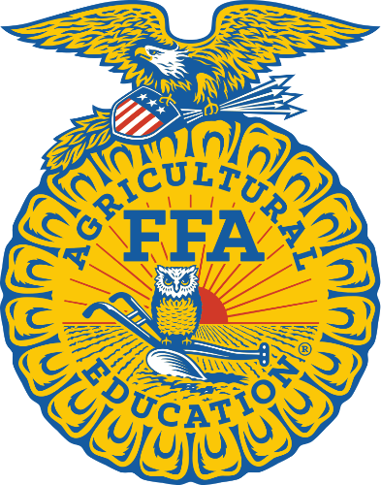

“If you got a dream, chase it, ‘cause a dream won’t chase you back.”
– Cody Johnson

2023-2024

Dear Parents/Guardians and FFA Members,
Your child(ren) has shown an interest and commitment to becoming a member of the Paynesville Area FFA Chapter. This Program of Activities (POA) booklet is for you and your child(ren) to review and become aware of what FFA is about and the opportunities that are offered throughout the year. It contains a brief chapter program overview, condensed version of the POA events, and a tentative calendar of FFA activities.

FFA Fun Facts:
- FFA was formed in 1928. The Paynesville chapter has been going strong since 1947!
- FFA was originally known as “Future Farmers of America,” however in 1988 it was changed to the “National FFA Organization” to reflect the diversity of agriculture and its opportunities.
- FFA is the nation’s largest youth organization.
- FFA makes a positive difference in the lives of students by developing their potential for premier leadership, personal growth and career success through agricultural education.
- Minnesota has 30 different contests that FFA members can participate in that Career or Leadership Development Events (CDE’s or LDE’s).
- Students in grades 7-12 can join FFA that have an ag class taught by Mrs. Utsch. The National FFA bylaw states that to be an active member, a member must be enrolled in an ag course during the year.
- Students have the opportunity to travel as they explore leadership and career opportunities that will help them as they get older.
- There is a $25.00 membership fee (Due October 16th) that is split up between the national, state, region, chapter levels and a free T-shirt.
- Our chapter and the activities are funded completely with our fundraised money which we get from the educational plot south of the school and fruit sales. The chapter also receives a little money from the corn drive and pizza.
- Students can win prizes, awards, and even letter in FFA. Each activity a member participates in they receive points towards lettering and awards. The more active a member, then the more points they receive.
- We have some exciting events planned for the year such as the Meetings & Activities, Octoberfest, Redneck Olympics, Bonfire, FFA Week and many other events.

I will do my best in keeping you informed of different opportunities and changes throughout the year. Please feel free to contact me with any questions or comments at the school (320-243-3761 x 1171) or email me at nutsch@isd741.org. We have a great officer team and we are all very excited to spread the word about FFA and show our achievements. Come join us this year!!!!!

Sincerely,
Natalie L. Utsch
Ms. Natalie Utsch

What is FFA all about?

National FFA Organization Mission Statement:
FFA makes a positive difference in the lives of students by developing their potential for premier leadership, personal growth, and career success through agricultural education.

Paynesville Area FFA Mission Statement:
Paynesville Area FFA is a student run leadership organization honoring agricultural opportunities hand in hand with our community.

Chapter Officers:
President Hailey Ruhoff
Vice President Krista Hurd
Secretary Taylor Bierwerth
Treasurer Carter Fuchs
Reporter Kadyn Kulzer
Sentinel Owen Abraham
Parliamentarian Vincent Westlund
Officer-At-Large Jesse Weber
Advisor Mrs. Natalie Utsch

FFA Opportunities
- Career Development Events (CDE) – develop technical knowledge, judgment, reasoning, and sportsmanship
  - Judging: Dairy, General Livestock, Horse, Poultry; Fish and Wildlife, Ag Mechanics, Job Interview, Ag Sales, Speaking, Dairy Products, Meats, Forestry, Soils, Small Animals, Floriculture, etc.
- Leadership Development Events (LDE) – Parliamentary Procedure, Employment Skills, Prepared Public Speaking, Extemporaneous Speaking, etc.
- Supervised Agricultural Experiences (SAE) – a project where you keep records of an agricultural thing you own or work you do on the farm, community, job, etc. (an SAE project is required for degrees, awards, national scholarships)
  - Examples: owning cattle, milking, lawn mowing, working at grocery store, floral shop, golf course, crop farming, construction, selling: feed, farm equipment, farm insurance, etc.
- Traveling – region contests in different towns, tours, conventions, camps, conferences
- Friendships – meet new people from different schools and chapters across the state and nation (FFA national convention)
- Career Exploration – explore various career options and learn skills with hands on opportunities

Paynesville Area FFA 2023-2024
Program of Activities (POA)

Each chapter builds its POA around 3 major divisions that focus on the types of activities a chapter conducts. Each division has 5 quality standards which are listed in the left column. The activities our chapter participates in are listed in the right column.

Division I – Growing Leaders
The purpose of this division is to encourage the chapter to develop individual and cooperative activities that will enhance students’ life skills.
Leadership: Activities that help the individual develop technical, human relations and decision-making skills to grow leaders | - Region & State Career Development Events (CDE/LDE)  - Leadership Conferences/Camps (SGLC, SLCCL, INTENSE, WLC)  - Parliamentary Procedure Lessons  - Officer Retreat
Healthy Lifestyle: Activities that promote the well-being and self-esteem of the student, either mentally or physically. | - September –Pickleball & Volleyball & Ice Cream Social  - October – Octoberfest & Pumpkin Bowling & Pumpkin Carving/Painting & Cornhole  - November – CDE Olympics & Nachos  - December – Fruit Delivery  - January – Cosmic Bowling  - February –Redneck Olympics  - March – Kickball w/ Alumni & Supporters & Families  - April – Barndance, State Convention  - May – Banquet, Bonfire  - June – Parade  - July –Fairs  - August – State Fair/Officer Retreat
Scholarship: Activities that develop a positive attitude toward lifelong learning experiences. | - Scholarship Interviews  - Scholarship Awards  - National Scholarship Award
Personal Growth: Activities conducted that improve the identity and self-awareness of members. These activities should reflect members’ unique talents and potential by reinforcing their human and employability skills. The activities should strive to enhance the quality of life and contribute to members’ life goals and development. | - Member Degrees  - Workshops at State and National Conventions  - FFA Lettering Awards
Career Success: Activities that promote student involvement and growth through agriculture related experiences and/or entrepreneurship and promote career readiness. | - Officer and Scholarship Interviews  - Career Show at State and National Conventions  - Spring Tour  - 8th Grade Ag Career Day (tentative)  - SAE Projects and Records  - Proficiency Applications/Interviews  - Fruit & Snack Sales  - Pizza Sales

Division II – Strengthening Agriculture
The FFA chapter has a responsibility to provide opportunities and services to its members.
Support Group: Activities conducted to develop and maintain positive relations among FFA, parents and community leaders interested in supporting agricultural education. | - Alumni & Supporters Appreciation (appetizers & beverages for alumni & supporters meeting)  - Alumni & Supporters & Family Kickball  - Chapter Banquet  - Staff Appreciation (desserts)
Chapter Recruitment: Activities conducted to increase agricultural education enrollment and/or FFA membership and encourage greater participation. | - Summer Sizzler  - Corn Drive  - FFA Week Activities  - Amazing Members Race  - World’s Toughest Rodeo
Safety: Activities that enhance safety in the community. | - Ag Day at the Elementary School (animal & tractor/equipment safety demonstrations)
Agricultural Advocacy: Activities conducted to articulate and promote agricultural programs, practices, policies and/or education to elicit action. | - Newspaper Publicity  - Website  - Facebook Page  - Instagram  - Scrapbook  - Chapter T-Shirts (for all members)  - Paynesville Town & Country Days Parade  - Interviews (Radio and TV)
Agricultural Literacy: Activities that help consumers become better informed about the production, distribution and daily impact of food, fiber and fuel. | - Teach Ag Day  - Plot Education

Division III – Building Communities
FFA can develop partnerships with other groups and organizations to exert a leadership role in making the community a better place to live and work.
Environmental: Activities conducted to preserve natural resources and develop more environmentally responsible individuals. | - Adopt-a-Highway
Human Resources: Activities conducted to improve the welfare and well-being of members and citizens of the community. | - Nursing Home Activities (candy trucks and games)  - Drive in Style & Parade Past Senior Centers
Citizenship: Activities conducted to encourage members to become active, involved citizens of their school, community and country. | - Troop or Treat
Stakeholder Engagement: Activities conducted to develop teamwork and cooperation between the local chapter and stakeholders. | - Anez Consulting Customer Appreciation Serving  - Plot Day
Economic Development: Activities conducted to improve the economic welfare of the community. | - Region 3 Monthly Challenges (school supply drive, food drive, etc.)

FFA Code of Ethics
FFA members conduct themselves at all times to be a credit to their organization, chapter, school, community, state, and family. As an FFA member, I pledge to:
- Develop my potential for premier leadership, personal growth, and career success.
- Make a positive difference in the lives of others.
- Dress neatly and appropriately for the occasion.
- Respect the rights of others and their property.
- Be courteous, honest, and fair with others.
- Communicate in an appropriate, purposeful, and positive manner.
- Demonstrate good sportsmanship by being modest in winning and generous in defeat.
- Make myself aware of FFA programs and activities and be an active participant.
- Conduct and value a supervised agricultural experience (SAE) program.
- Strive to establish and enhance my skills through agricultural education in order to enter a successful career.
- Appreciate and promote diversity in our organization.
- To participate in out of school FFA activities, maintain a C average and have no D’s or NC’s as well as have a satisfactory attendance record.
- Be a full time student at PAHS High School.
- Have no current debts to the PAHS FFA.

Official Dress (OD)
FFA events at the chapter level do not require OD, unless stated. Most region contests do NOT require OD, however parliamentary procedure, speaking, employment skills, and food science contests do. OD is required at state and national conventions, conferences, camps, region banquet, and the chapter banquet (for those that have it).

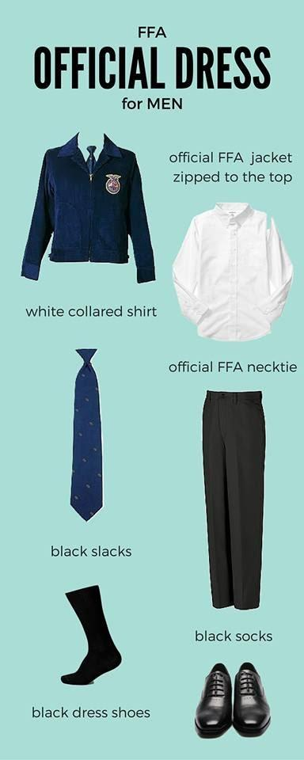 | - Women can wear ties too if they don’t have a scarf.  - An official necktie is not necessary, you can wear any navy blue or black tie.  - Women can wear black dress pants also (not yoga or workout pants).  - Black boots are okay too. | 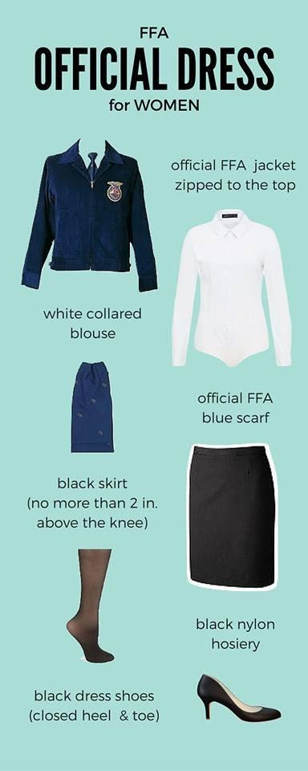

Proper Use of the FFA Jacket
- The FFA Jacket is the most recognizable symbol of our organization. As a member, one of your responsibilities it to ensure its proper use.
- Jackets are available for purchase through the advisor for ~$60.00, scarves are approximately $13.00, ties are approximately $16-25, plus shipping and handling.
- Members are encouraged to purchase a jacket, however, that may not always be possible. The Paynesville FFA has several jackets and ties available for loan for various official FFA events.
- There are also ways for members to win free jackets.
  - Only members wear the jacket.
  - The jacket should be kept clean and neat.
  - Besides official emblems, name of chapter and state, a jacket includes your name, office, and year if appropriate.
  - The jacket should always be worn to official occasions with the zipper fastened to the top, the collar turned down, and sleeves buttoned.
  - It may be worn to all official FFA occasions where the chapter or state should be represented.
  - The jacket should only be worn to places appropriate for members to visit.
  - Other insignia should not be attached to the jacket.
  - A member should act appropriately when wearing the jacket.
  - Members should refrain from the use of tobacco and alcohol at all times when representing the FFA. In addition, members should exhibit their leadership qualities when they encounter substances including tobacco and alcohol and serve to discourage others from inappropriate behavior.
  - All chapter degree, officer, and award medals should be worn beneath the name, with exception of the state degree charm. No more than 3 medals should be worn. These represent: highest degree earned, highest office, and highest award earned.

2023-2024 Paynesville Area FFA Chapter Officers
President  Hailey Ruhoff | Vice President  Krista Hurd | Secretary  Taylor Bierwerth
Treasurer  Carter Fuchs | Reporter  Kadyn Kulzer | Sentinel  Owen Abraham
Parliamentarian  Vincent Westlund | Officer At Large  Jesse Weber | Advisor  Mrs. Natalie Utsch  Paynesville Area High School  795 Business Hwy 23  Paynesville, MN 56362  320-243-3761 x 1171  nutsch@isd741.org
FFA Website  http://paynesvilleareaffa.weebly.com/ | Ag Dept. Website  https://www.paynesvilleschools.com/apps/pages/index.jsp?uREC_ID=1025306&type=u | Follow us on Facebook  Check us out on Instagram  paynesvilleareaffa

